NAME: Talari Vyshnavi

USER ID: 34725-batch 5

E MAIL: [talari.vyshu@gmail.com](mailto:talari.vyshu@gmail.com)

# TOPICS :-

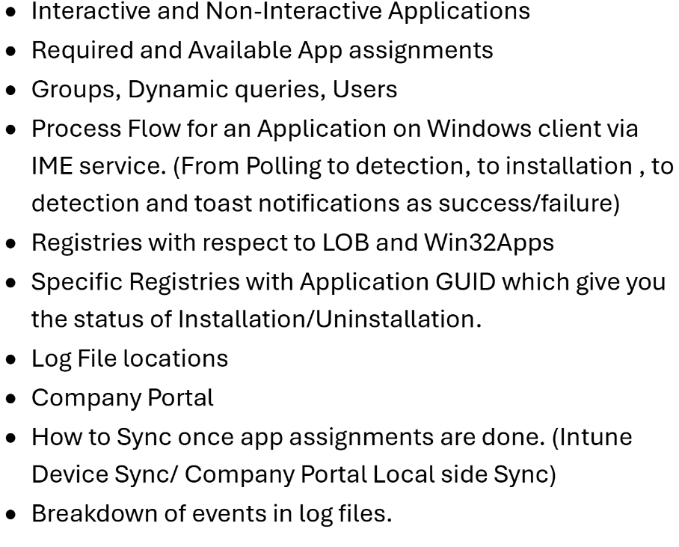

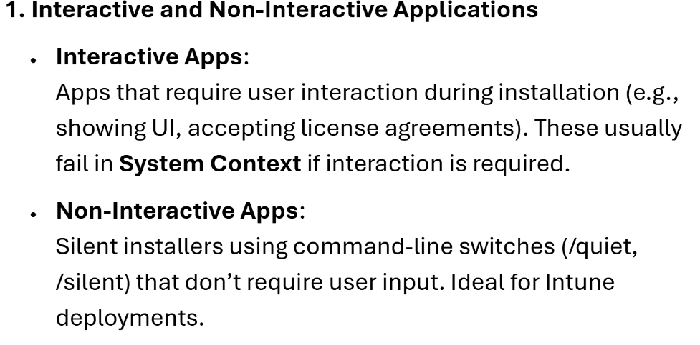

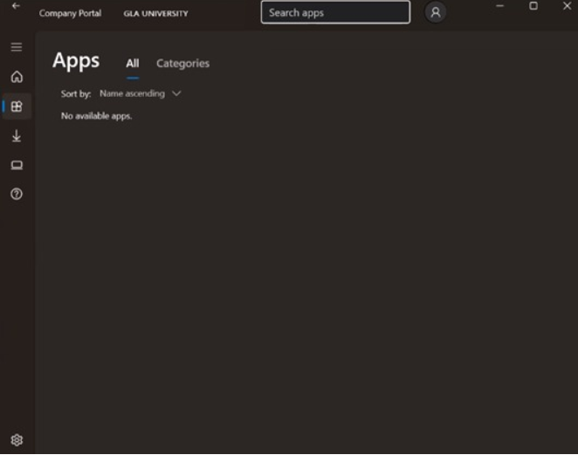

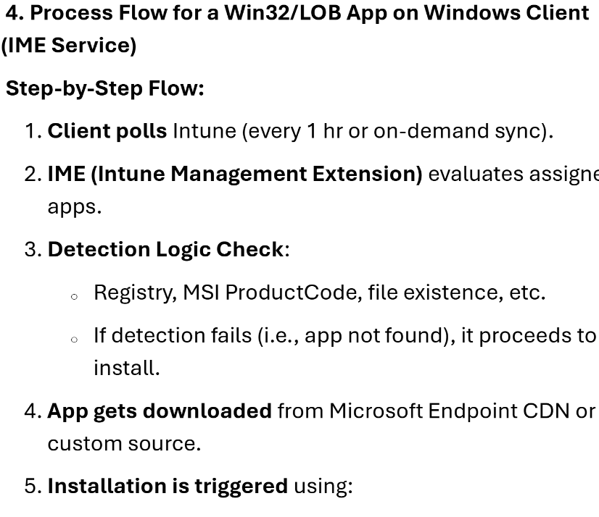

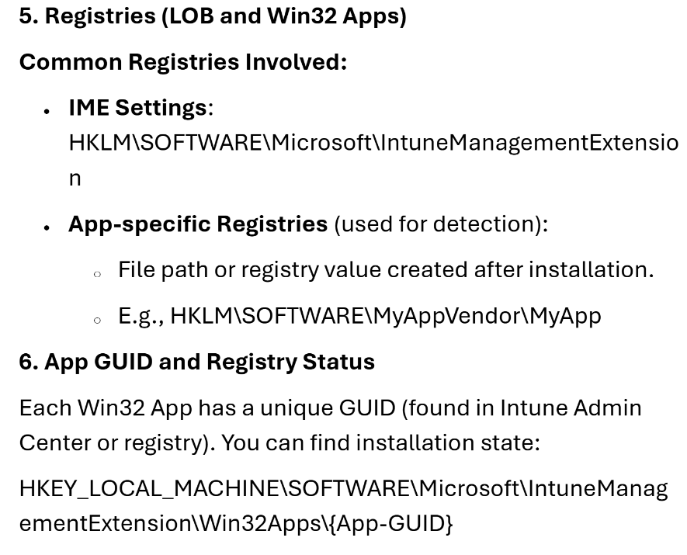

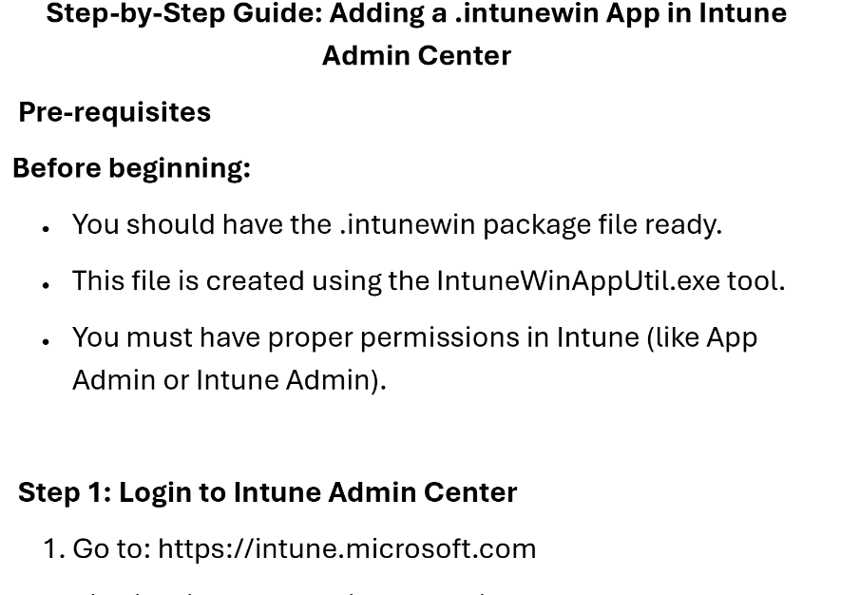

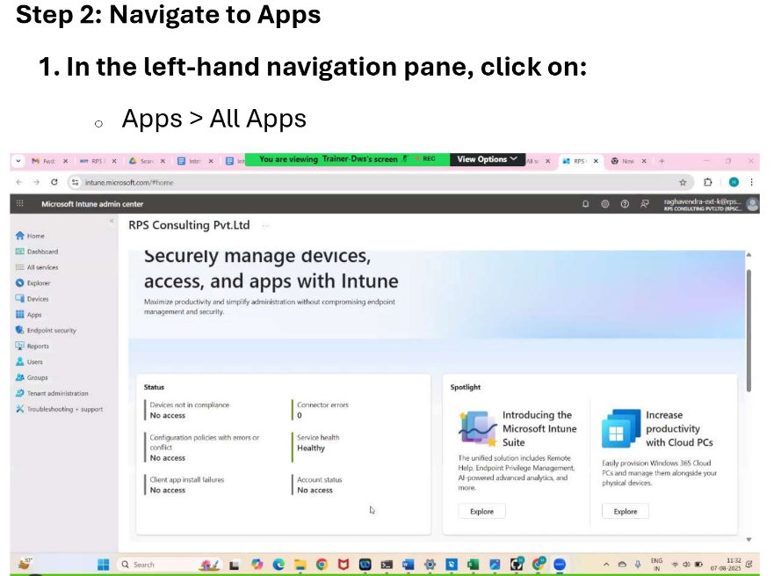

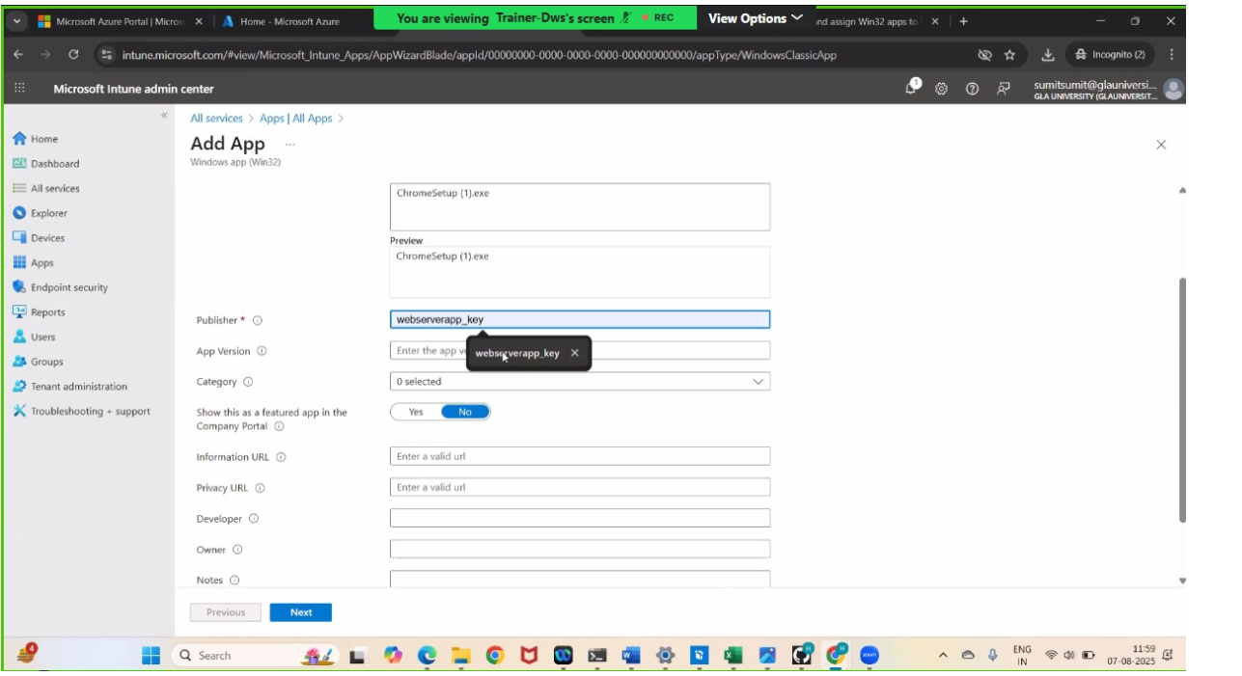

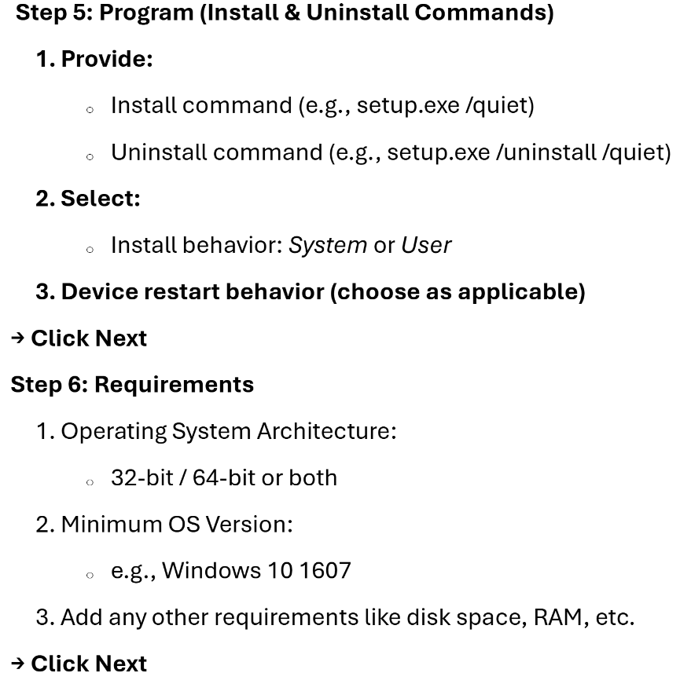

**Step 7: Detection Rules**

**Define how Intune will detect if the app is already installed:**

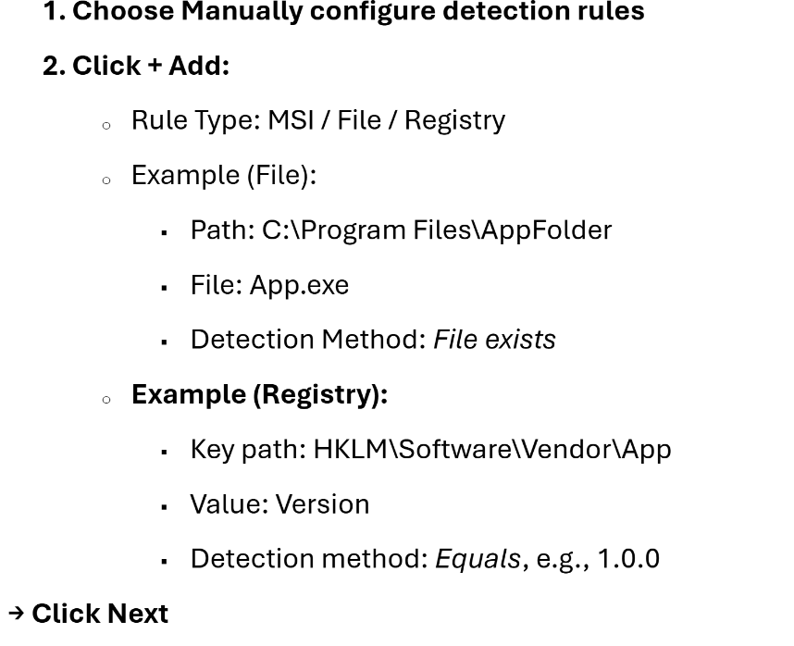

**Step 9: Review + create**

* Review all your settings

